### The Nim Programming Language in 10 Minutes


## BASIC SYNTAX
# Nim File = module
# Library = package
# Function = proc (procedure)
# Object Variables = fields
# Constants = const (static at compile-time)
# Variables = var (can change at runtime)
# Immutable Variables = let (set once at runtime and cannot change)
# Linked List = seq
# Map/Dictionary = Table
# Null = nil
# Pointer = ptr
# Tuples, Sets, and More Also Available

# QUIRKS: The character * denotes exposure of this data structure or function to external libraries. There is no "public" reserved keyword to expose an entire module; every object field must be individually marked as exposed. If you're doing systems programming and coming off C/C++, remember that * is an export marker while ptr is pointer
You control every byte with pragmas and memory-management. Its static typing and "strict effects" system catch bugs before they ever reach a user. Its macro system lets you rewrite the language itself to create custom "Domain Specific Languages".
But…
Because it allows you to bypass safety checks (like {.unchecked.} or cast[]) and talk directly to C, you can cause low-level memory crashes that are impossible in languages like Java or Python. Great for low-level systems work, like building an operating system – not exactly the go-to for your little brother’s first foray building a Roblox mod.

# Comments: Start at Hash/Pound Sign, End at Newline Beginning
PseudocodePseudocodePseudocode
PseudocodePseudocodePseudocodePseudocode # No real Nim yet

# Code Block Structure: Indent (e.g. YAML/Python)
PseudocodePseudocodePseudocode
PseudocodePseudocode
Pseudocode

# Naming Convention: Style Insensitivity, Word Fragments, All-Lowercase
proc, var, enum, notin, isnot

# Colon Type Hints
name: type
# Import Declarations
import package
import package2 as m

## DATA STRUCTURES
## Numericals: Fixed-width, signed/unsigned, fixed/floating
var foo1: int64 # 64-bit, exactly 8 bytes
var foo2: uint8 # Exactly 1 byte
var foo3: float32
# Arrays: Flexible Allocation, Dotted Ranges
var colors: array[3, string] = ["red", "green", "blue"]
var colors2: array[0..2, string]

# seq: Dynamically-sized Array
var names: seq[string]
names = @["Alice", "Bob"] # '@' turns an array into a seq
# @ is NOT for general casting
names.add("Charlie")

# Table: Key-Value Pairs
import tables
var scores = initTable[string, int]()
scores["Player1"] = 10
scores["Player2"] = 14

# proc: Nim's functions
proc add(x: int, y: int): int = # <- The '=' starts the logic
let sum = x + y # This is the indented block
return sum

#Objects
type
Player = object
name = string
hp = int
# The type keyword at the top is required for the beginning of type declaration blocks
# Nim pushes you to consolidate type declarations in your modules into few or one block(s)

## BASIC CONTROL FLOW
# if / elif / else
if foo1 > 0:
echo "positive"
elif foo1 == 0:
echo "zero"
else:
echo "negative"

# while loop
var i = 0
while i < 10:
echo i
inc i

# for loop over range
for i in 0 ..< 10: # 0 to 9
echo i

# for loop over seq
for name in names:
echo name

# Simple Error Handling: raise/try/except
proc mightFail(x: int) =
if x < 0:
raise newException(ValueError, "x must be non-negative")
try:
mightFail(-1)
except ValueError as e:
echo "Caught error: ", e.msg
# Entry Point (main)
# Nim looks for a 'main' module; you choose the start proc.
proc main() =
echo "Hello from Nim"
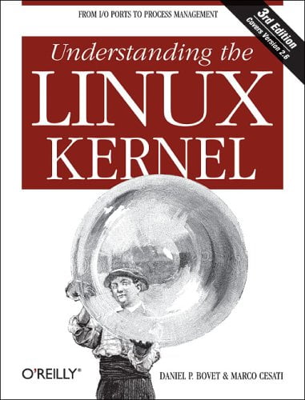
when isMainModule:
main()

## ADVANCED SYNTAX
# Grouped Declaration
var a, b, c: int
let name, city, job: string = "Pending"
proc calculate(a, b: int, x, y: float32): float32 =
# note the equals sign at the end; this denotes the end of the declaration and start of
# body. Without it, you get this line that is a one-line proc – also usable.
proc add(x, y: int): int

# Pragmas: hints to the compiler, written inside {. .}
# For Variables: var name {.pragma.}: type
# For Procedures: proc name() {.pragma.} =
# For Objects: type MyObj {.pragma.} = object

# Example: {.align.} pads a type to align to a specific memory address (useful in low-level work)
var x {.align(4096).}: array[4096, byte]

# {.align(N).}: Forces variables to start at specific memory addresses.
# {.packed.}: Removes hidden padding between object fields to save space.
# {.unchecked.}: Disables bounds checking for faster, "unsafe" array access.

# {.union.}: Makes all object fields overlap in the same memory slot.
# {.inline.}: Suggests the compiler copy-paste code instead of calling it.
# {.noSideEffect.}: Guarantees a pure function that only relies on inputs.
## A func is just a shorthand for a procedure with the {.noSideEffect.} pragma.
# {.noreturn.}: Tells the compiler this procedure never exits (like quit).
# {.discardable.}: Allows calling a function without using its return value.
# {.importc.}: Links a Nim procedure to an external C function.
# {.exportc.}: Makes a Nim procedure callable from C code.
# {.header.}: Specifies the C header file containing an imported function.
# {.cdecl.}: Sets the calling convention to match standard C libraries.
# {.deprecated.}: Marks code as obsolete and warns users during compilation.
# {.error.}: Triggers a hard stop if this code is compiled.
# {.warning.}: Displays a custom message during the compilation process.

# Templates: These are compile-time "fancy find-and-replace" code generators. They # look like procedures but work like macros.
# Example Simple Template
template debugEcho(x: untyped) =
echo "DEBUG ", astToStr(x), " = ", x
var n = 42
debugEcho(n) # expands to an echo at compile time

# Macros: Nim’s most powerful feature. Macros are code that writes other code while the compiler is running.
# Example Simple Macro
import macros

macro dumpType(T: typedesc): untyped =
echo "Type is: ", $T
result = newStmtList() # generates no runtime code

dumpType(int)
dumpType(Player)

# Ref Objects: In Nim, a standard object is a "value type" (stored on the
# stack). If you want a "reference type" (stored on the heap, like a Java object), # you call it a ref object.

type
PlayerRef = ref object
name: string
hp: int
var pr: PlayerRef = PlayerRef(name: "Alice", hp: 100)
pr.hp = 80

# UFCS (Uniform Function Call Syntax)
# Example: Calling a proc on an object
proc takeDamage(p: var Player, amount: int) =
p.hp -= amount
var p2 = Player(name: "Bob", hp: 120, level: 1)
takeDamage(p2, 20)
p2.takeDamage(20) # UFCS

# If there are no remaining arguments, you can even drop the parentheses entirely:
proc heal(p: var Player) =
p.hp += 10
heal(p2) # normal
p2.heal() # UFCS with ()
p2.heal # UFCS without (), when there are zero args

## Low-Level Workflow Points of Note
# Example: Casting and Pointer Work
var buf: array[16, byte]
var pInt = cast[ptr uint32](addr buf[0]) # reinterpret start as
# uint32 pointer
pInt[] = 0xDEADBEEFu32

# Example: Disable bounds checking in a hot loop
proc sumUnchecked(a: ptr int32, n: int): int32 {.unchecked.} =
var s: int32 = 0
for i in 0 ..< n:
s += a[i]
result = s

That concludes this short work that can get you up to speed to start coding or reviewing your agent’s work. This has been something aimed at getting you useful, but there are numerous rsources to both learn more and get involved in the growing Nim community.
#Documentation:
Official Docs (See Next Page): https://nim-lang.org/documentation.html
Official Nim Manual: https://nim-lang.org/docs/manual.html
Third-Party Docs: https://github.com/Balans097/NimAPI
Nim Source: https://github.com/nim-libs/nsis

#Socials:
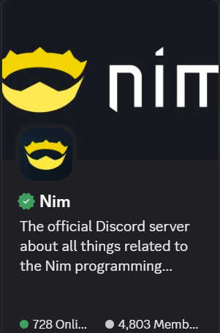

Official Forum: https://forum.nim-lang.org/
Twitter/X: https://x.com/NimDiscussions
Reddit: https://www.reddit.com/r/nim/
Live Chat: IRC (#nim on Libera.Chat), Gitter (gitter.im)
Official YouTube Channel: https://www.youtube.com/channel/UCDAYn_VFt0VisL5-1a5Dk7Q/videos
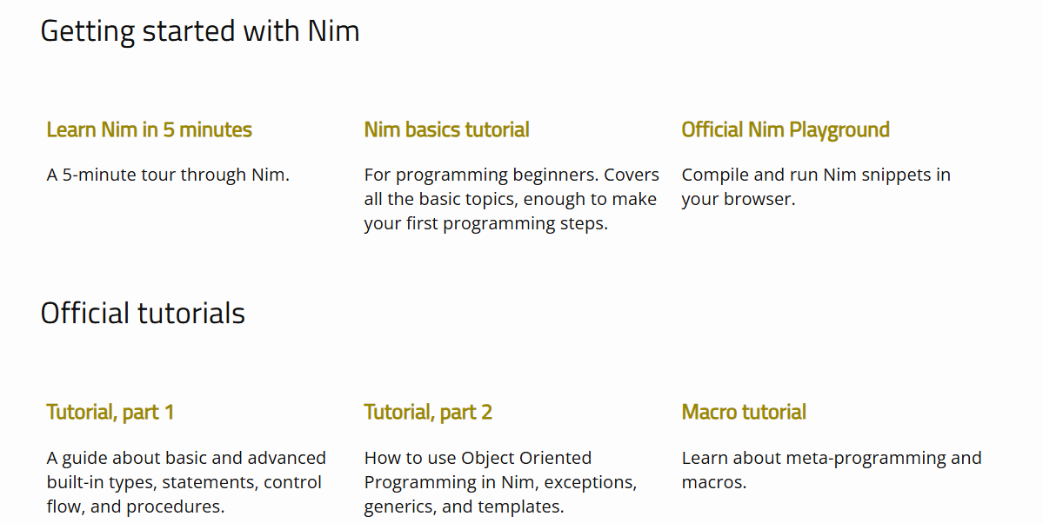
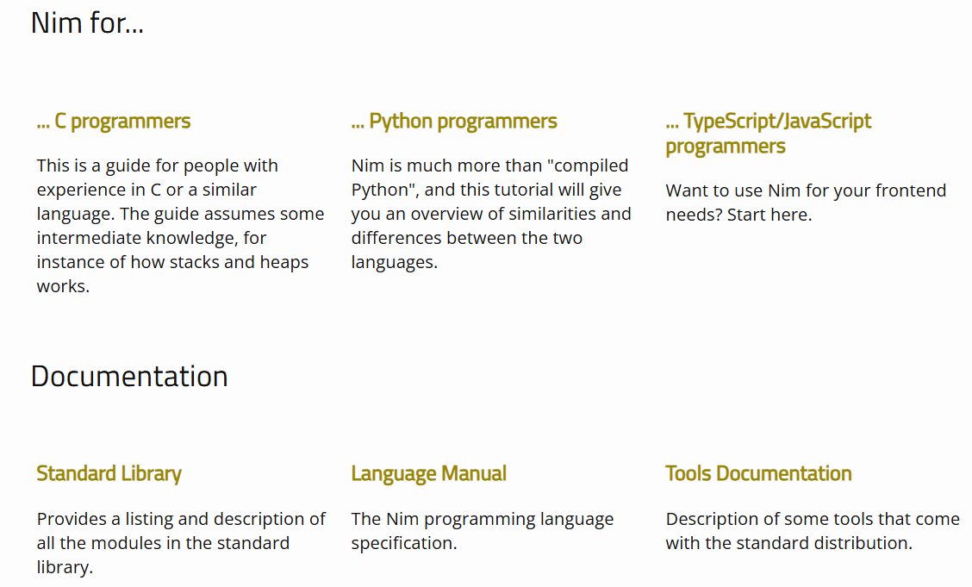
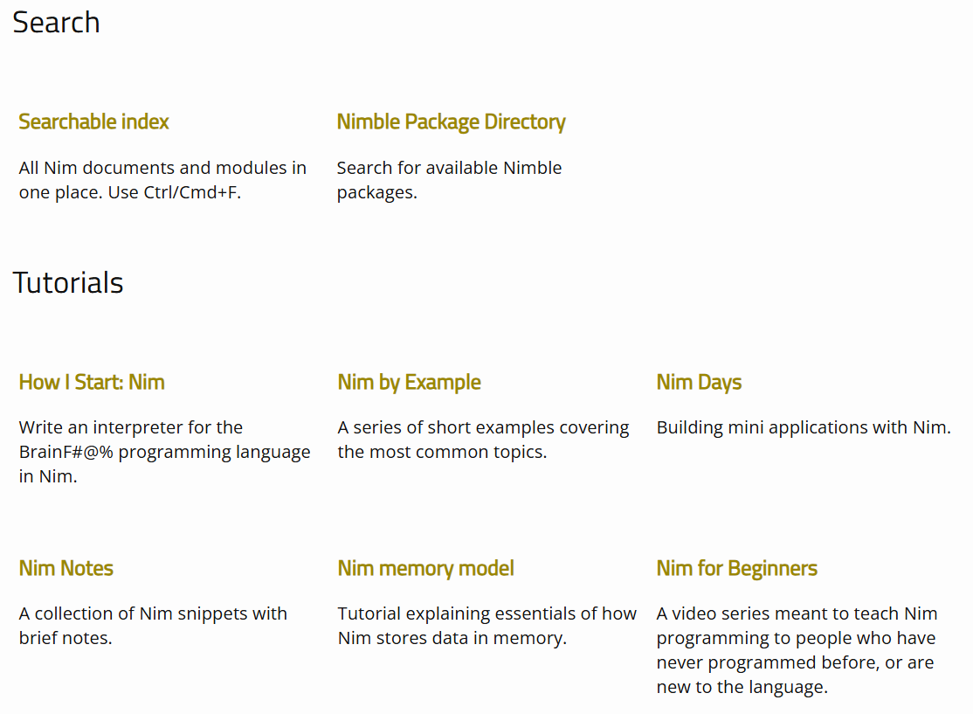
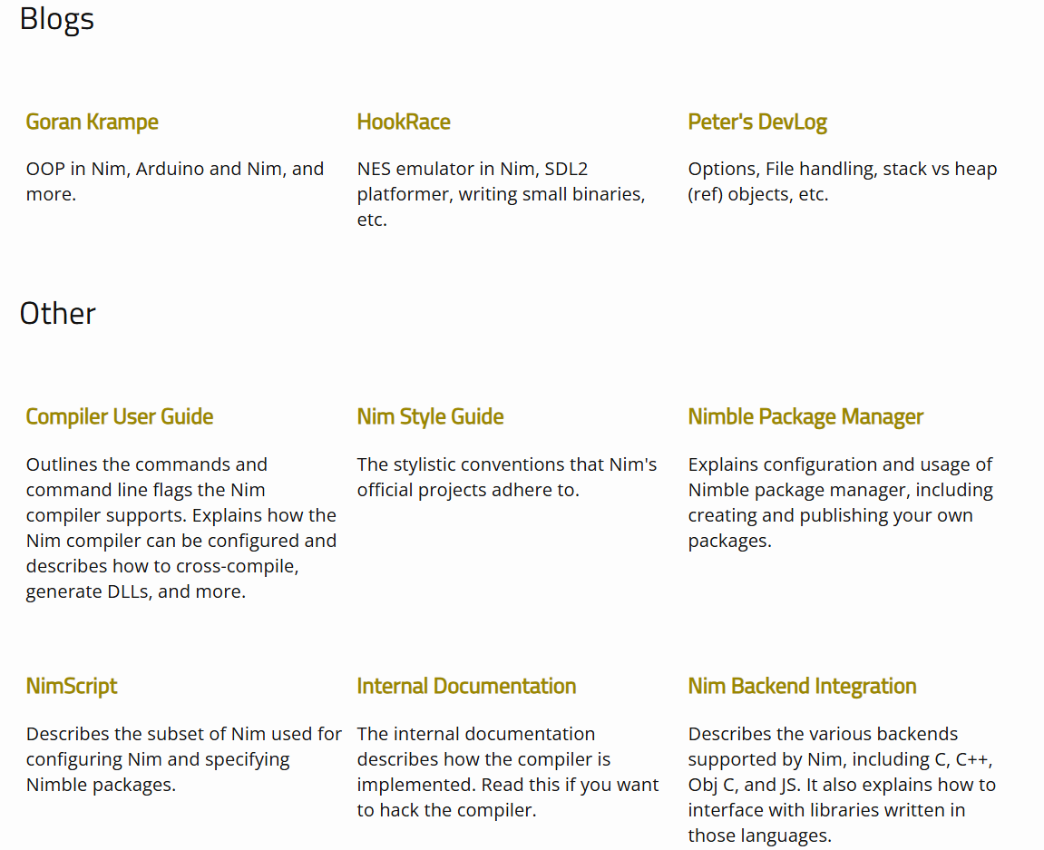
Books:

Mastering Nim: A complete guide to the programming language
Andreas Rumpf (Creator of the Nim language)
https://nimprogrammingbook.com
This book can still be found free online, although the author recently took his hosted copy down and now sells it through Amazon.

Nim Basics
Miran
https://narimiran.github.io/nim-basics/
(Free)

The Status Nim Style Guide
https://status-im.github.io/nim-style-guide/
(Free)

Courses, Example Code & REPL Interactive Web & Local Dev Env

https://exercism.org/tracks/nim
https://nim-by-example.github.io/
https://rosettacode.org/wiki/Category:Nim
https://www.youtube.com/user/kiloneie/playlists
https://replit.com/languages/nim
https://github.com/inim-repl/INim

Curated List of Available Packages

https://github.com/ringabout/awesome-nim

Includes embedded systems OS’s, backup tools, science & data tools, database solutions, multimedia, text and webpage parsing and manipulation, various blockchain and cryptography algorithms, terminals, GUI’s, network protocols and messaging, web servers, gaming engines and development frameworks, software development frameworks and toolchains, as well as a long list of Nim language resources.
Appendix: A Final Word - Operating Systems written in Nim

Lastly I’d like to say that I am currently working on building an OS almost completely in Nim called nimos. as a Proof of Concept (PoC). There are already some embedded systems OS’s/firmware (listed in the last link given on the prior page).

However, there are only two Nim OS’s I have found that go beyond a simple “boot to screen and done”.

The first, NimOS, is by Nimish Wadekar: a tiny, BOOTBOOT protocol boostrapped image whose init uses syscalls and launches device drivers and read-only virtual and physical filesystems, landing you into a shell. From there, you can load ELF64 binaries into memory alongside a small userspace of C libraries, and there is primitive IPC in the form of reserved uniform memory in RAM for messaging. This was pushed to GitHub in 2021 and looks as if it was the first visible attempt in this domain. However, it’s still very basic as there’s no true, modern IPC, no writable disk, no privilege levels between user/kernel, and no management services by the OS for memory or jobs or otherwise. However, it proved a bootable kernel with an interactive shell written in Nim.
Link: https://github.com/dom96/nimkernel

The second is by Khaled Hammouda and is titled Fusion OS. This second work went deeper and more formally crossed into the true OS domain by implementing basic resource management. While it didn’t integrate a filesystem, it matched NimOS by incorporating an ELF loader, a small userspace library, device drivers, and a slightly larger and more formal set of syscalls. It went further by building a custom UEFI bootloader for the image, loading a higher-half kernel single address space environment. But where it really trailblazed for Nim was by going into the management roles: virtual and physical memory management, thread management via separate kernel and user mode tasks alongside preemptive multitasking, priority-based scheduling, and hardware interrupts, as well as QNX-like channel-based IPC message passing. Future features listed as planned include demand paging, virtual and physical, a shell, GUI, networking, etc. He has extensively documented his journey. Probably the most interesting of all is his bespoke architecture design whereby privilege rings and single-owner queues for IO are implemented as a solution to long-running problems in the app space.
Source Link: https://github.com/khaledh/fusion
Docs Link: https://0xc0ffee.netlify.app/osdev/

